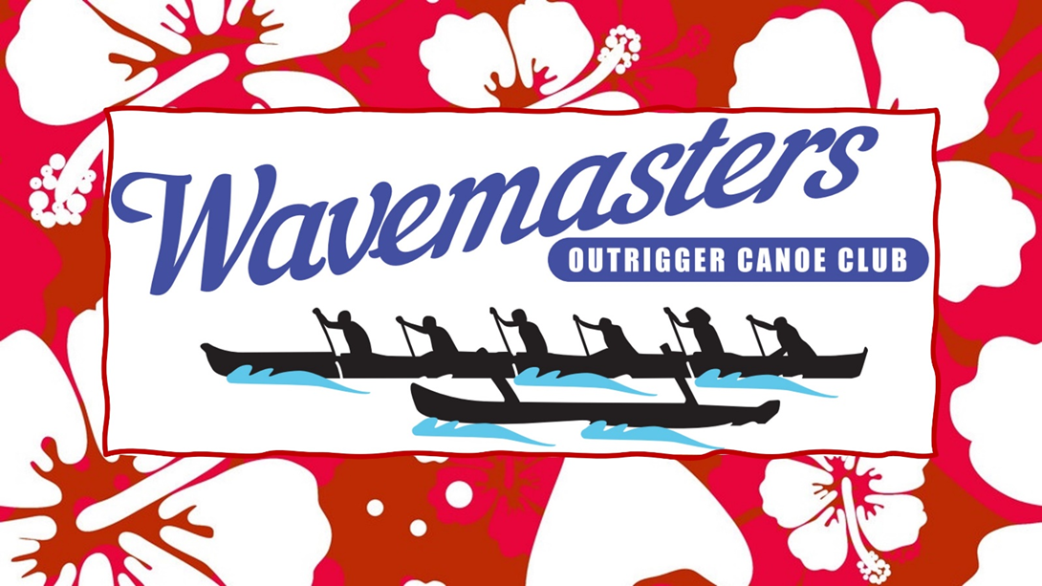

*Presents....*

The MONKEY’S

20 km beach relay

Koombana Beach

Saturday 10th Feb 2024



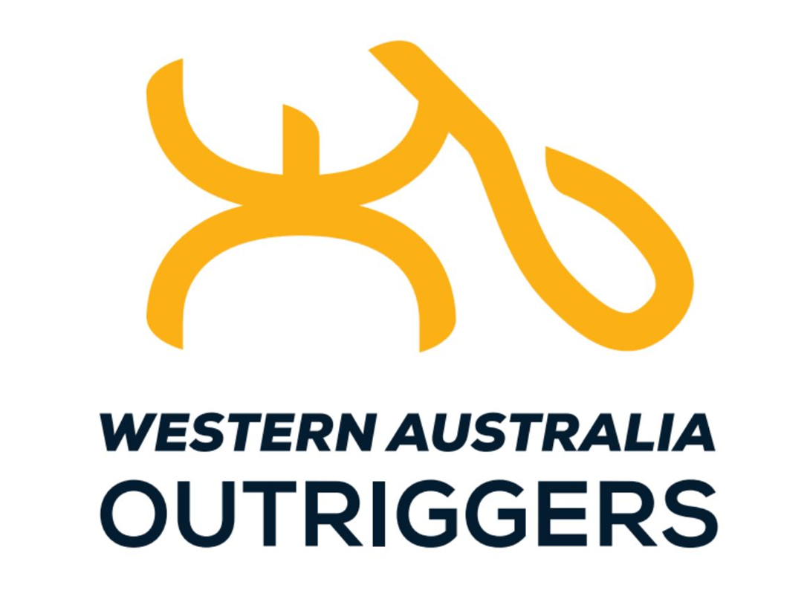

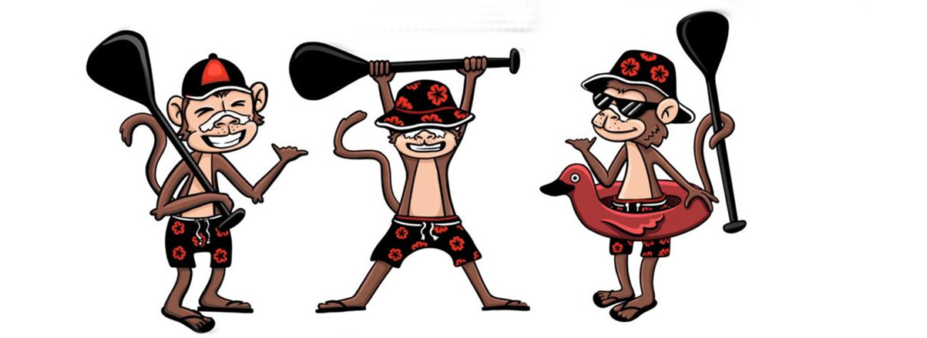

**RACE PROGRAM**

**9.00AM** Sign in and Scrutineering

**10.00AM** Race Brief

**10.30AM**  Race Start

**1.30PM** Presentations at Koombana.

***Entry***

$25pp via the AOCRA website.

Club Nominations due Saturday 03rd Feb.

Team Nominations due Saturday 03rd Feb.

***Teams***

Each leg must be MIXED crews only, maximum of 10 paddlers per team.

Boat ratio is 3men:3women, with exception to juniors rule; up to 2 male junior aged 14-16 can sit in a women’s seat.

Juniors…. 14-16 years will need a parental permission slip also signed by their coach. <file:///C:\Users\barga\OneDrive\Desktop\AOCRA%20Junior%20Parental%20Coach%20Approval%20Form%20F12%20Updated%20130122%20(1).pdf>

***Safety Equipment***

* All canoes must carry 6 x PFD’S types 1, 2, or 3. They must be secured and easily accessible.
* A minimum of 2 buckets or similar pieces of equipment to be used to bail out a canoe. They must be secured and easily accessible.
* A minimum of 1 spare paddle
* A towrope (of 25 metres minimum length by 12 mm diameter, SILVER ROPE, tied to the forward spreader, secured outside the covers and available for immediate use)
* Storm covers are permitted at any time and are compulsory at the discretion of the Race Director.

***Locations***

Race Event = Koombana Beach, Anchorage Cove, Bunbury.

Presentation’s, Koombana.

***Rigging***

Koombana Beach. Grassed area.



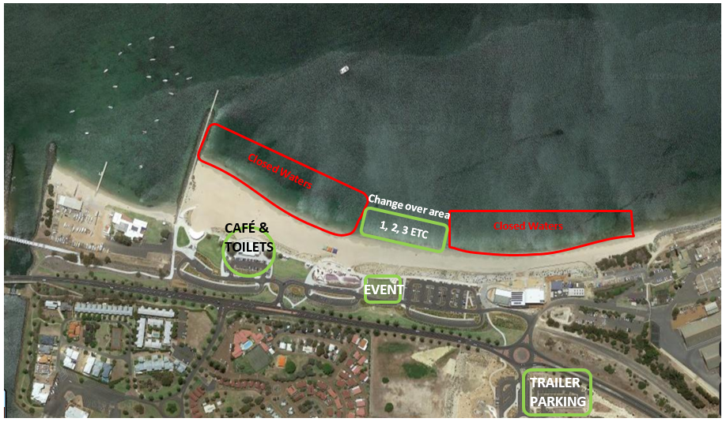

Change over zone is strictly enforced due to closed waters from Dept of Transport. Change over rules are first canoe in is the change at 1, second canoe changes at 2, etc. Ensure you listen carefully at the briefing.

Event Location is for First Aid, Rego, Briefing, Team tents and spectators.

4 laps of 5 km (20km) with crews swapping in shallow water at the beach.



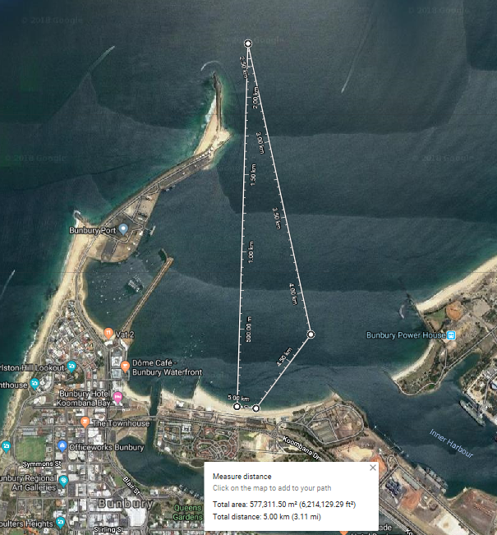

This course is subject to change, depending on conditions.

Run in accordance with AO rules.

<https://aocra.com.au/uploads/file/AOCRA%20Admin%20/2023%20March%20Aocra%20Rules.pdf>

**ALL PADDLERS ARE ENCOURAGED TO FOLLOW THE SUNSMART MESSAGE OF SLIP, SLOP & SLAP THROUGHOUT THE DAY.**

**ALL PADDLERS ARE TO ENSURE THEY ARE ADEQUATELY HYDRATED DURING**

**The race.**

